**MQTT with AWS EC2 Instance**

1. Create aws free tire account
2. Create ece2 instance searching ec2 instance &

* Give the instance a name

* Map the ec2 instance to key pair or create a new key pair

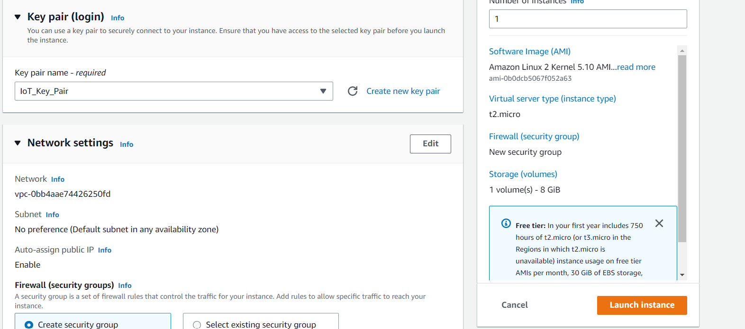

1. Generate private key using the aws key pair

* Open PUTTYKeygen
* Load the downloaded aws key pair to sign the public key
* Save the private key to be used to securely connect to the instance

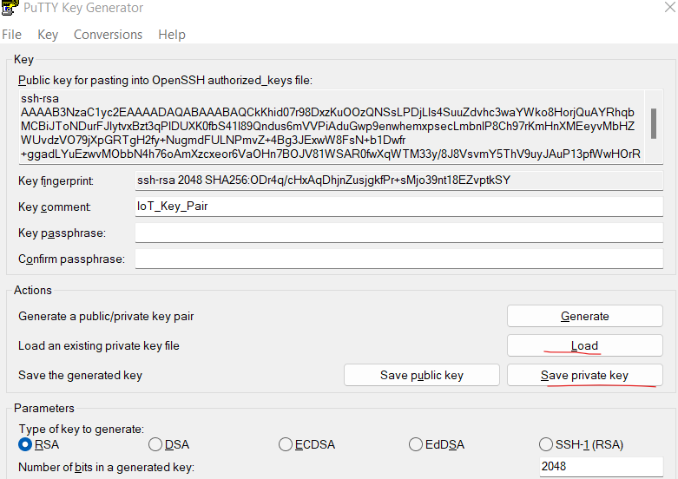

* Create ssh session using the ec2 instance IPV4
* Browse the private key under ssh>auth>credentials

* Open the ssh session and login as **ec2-user**
* Install mosquito:
* ***yum update***
* ***sudo amazon-linux-extras install epel***
* ***sudo yum -y install mosquitto***
* ***sudo systemctl start mosquitto***
* ***sudo systemctl status mosquitto.service***
* ***sudo systemctl enable mosquitto***

1. Connect the EC2 instance and use it as pub and ssh session as sub:

* ***mosquitto_sub -t IOT_Test -h localhost***
* ***mosquitto_pub -t IOT_Test -h localhost -m "Hello IOT Class?"***

***MQTT Setup on python***

* Install python
* Run CMD as admin
* cd dir to C:\Users\dootieno\AppData\Local\Programs\Python\Python310\Script
* pip3 install paho-mqtt --trusted-host pypi.org --trusted-host files.pythonhosted.org #paho-mqtt allows us to use python as subscriber & publisher
* on visual studio code execute the ***python MQTT_Subscriber.py*** on one terminal and ***python MQTT_Publisher.py*** on another